**CIS6300 Business Data Management**

**[Using Microsoft SQL Server Database]**

**MID-TERM**

**TAKE HOME**

**Fall 2019**

**Sampath Talluri**

**PART A:**

CREATE TABLE Mid_PRODUCT

(ProdID INT NOT NULL, ProdName VARCHAR (20), ProdDescription VARCHAR (20), SuggRPrice DECIMAL, CONSTRAINT mid_product_pk PRIMARY KEY(ProdID));

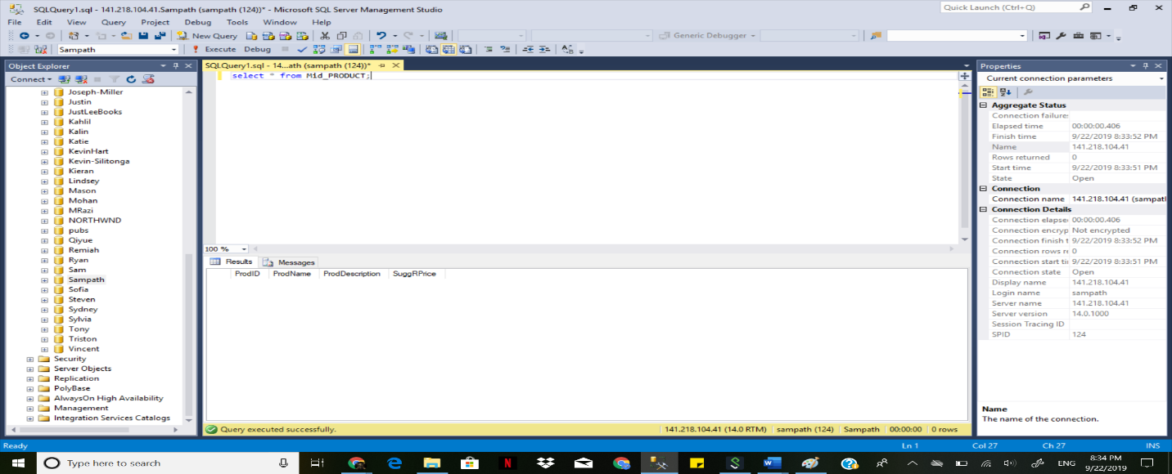

CREATE TABLE Mid_ORDER(ProdID INT, ProdQTY INT, OrderID INT, UnitCost INT,

CONSTRAINT pk_mid_order_orderid PRIMARY KEY (OrderID),

CONSTRAINT fk_mid_order_prodid FOREIGN KEY (ProdID) REFERENCES Mid_Product(PRODID));

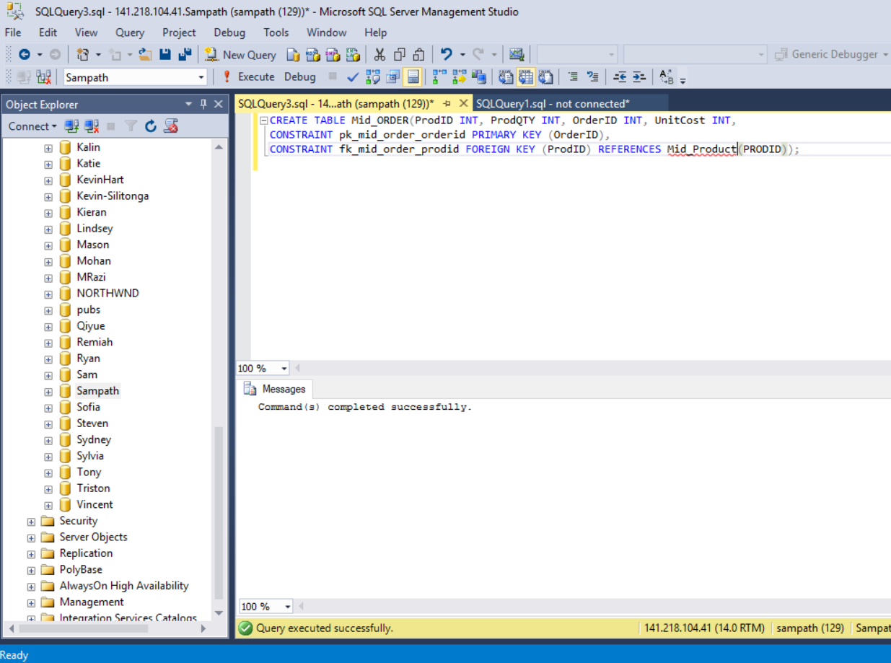

CREATE TABLE Mid_Customer (CUSTID INT, CUSTName VARCHAR(30), CUSTPhone INT, ORDERID INT

CONSTRAINT pk_mid_customer PRIMARY KEY (CUSTID)

CONSTRAINT fk_mid_customer_orderid FOREIGN KEY (ORDERID) REFERENCES Mid_Order (ORDERID));

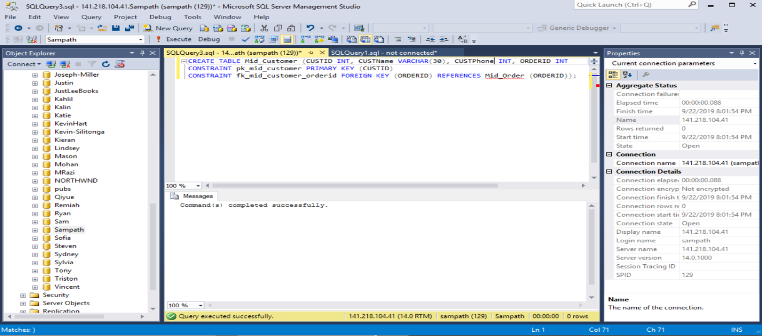

CREATE TABLE Mid_Part(PARTID INT, PARTNAME VARCHAR,

CONSTRAINT pk_mid_part_partid PRIMARY KEY (PARTID));

ALTER TABLE Mid_Part ADD CONSTRAINT partcost_mid_part_fk

FOREIGN KEY (PARTCOST) REFERENCES COST (PARTCOST);

ALTER TABLE Mid_part ADD CONSTRAINT qty_mid_part_fk

FOREIGN KEY (Quantity) REFERENCES Quantity (Quantity);

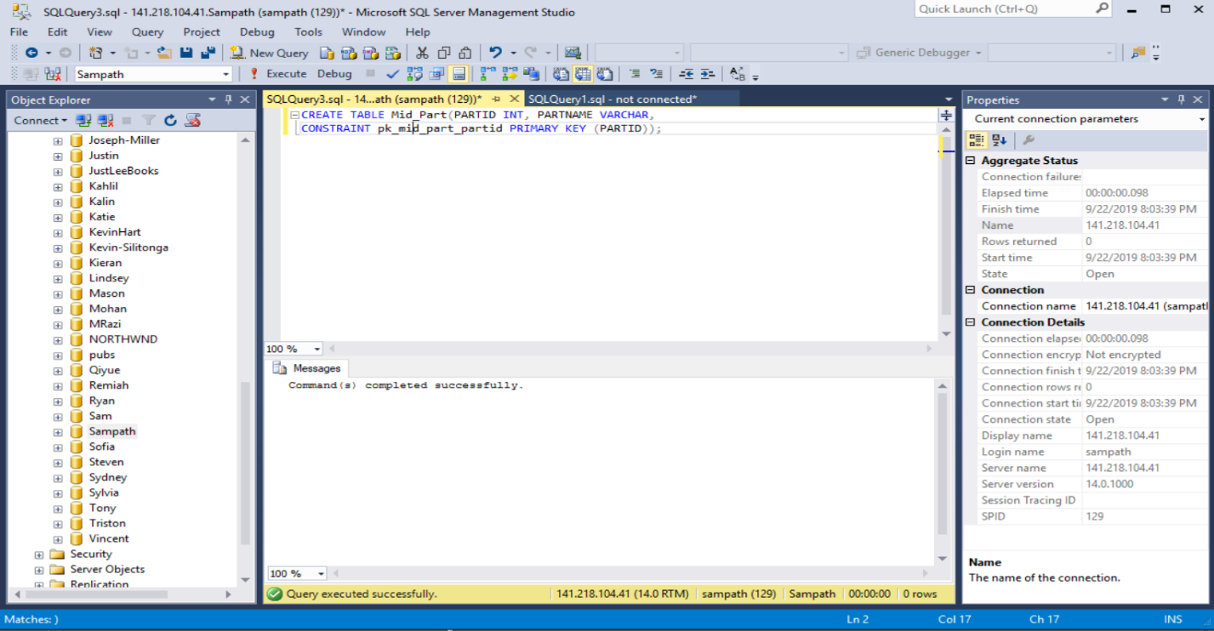

CREATE TABLE Quantity( PARTID INT, Quantity INT,

CONSTRAINT pk_quantity PRIMARY KEY (Quantity),

CONSTRAINT fk_partid_quantity FOREIGN KEY (PARTID) REFERENCES Mid_Part (PARTID));

ALTER TABLE QUANTITY ADD

CONSTRAINT suppid_quantity_fk FOREIGN KEY (SUPPID) REFERENCES SUPPLIER (SUPPID);

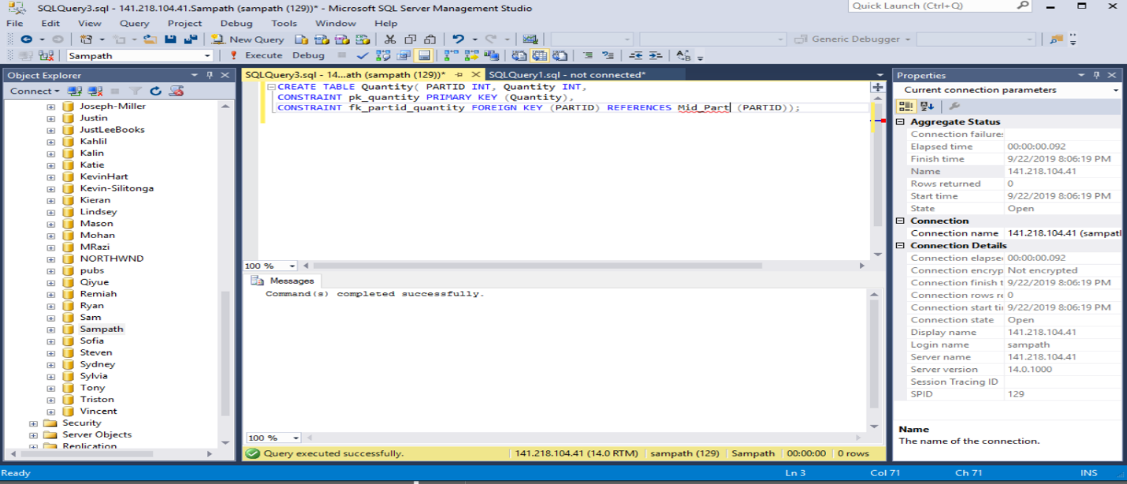

CREATE TABLE Supplier( SUPPID INT, SUPPName VARCHAR, SUPPPhone INT, Quantity INT,

CONSTRAINT pk_supp PRIMARY KEY (SUPPID),

CONSTRAINT fk_qty FOREIGN KEY (Quantity) REFERENCES Quantity (Quantity));

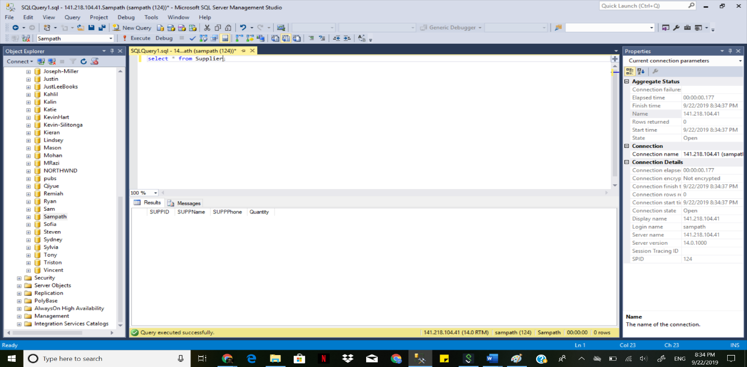

CREATE TABLE MidInventor(PARTID INT,PARTCOST INT, Quantity INT, QTYUsed INT, QTYAvailable INT, SuggRPrice INT, SUPPID INT,

CONSTRAINT partid_mid_part_fk FOREIGN KEY (PARTID) REFERENCES Mid_Part (PARTID),

CONSTRAINT partcost_cost_fk FOREIGN KEY (PartCost) REFERENCES COST (PartCost),

CONSTRAINT qty_quantity_fk FOREIGN KEY (QUANTITY) REFERENCES Quantity (Quantity),

CONSTRAINT suppid_supplier_fk FOREIGN KEY (SUPPID) REFERENCES SUPPLIER (SUPPID));

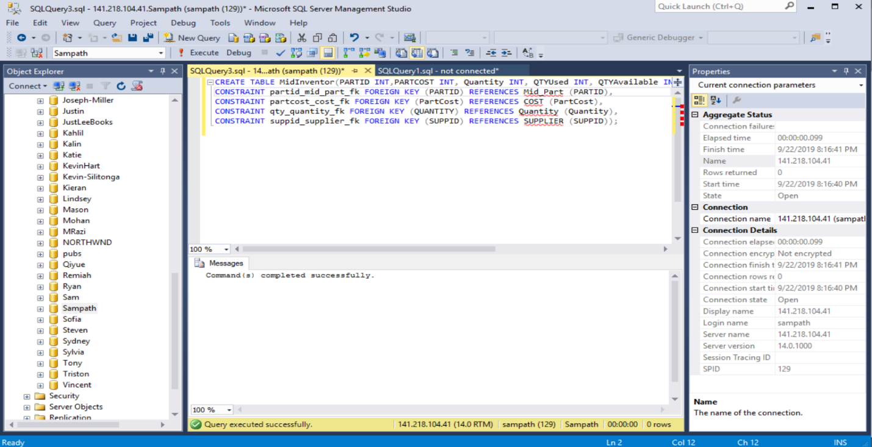

**ER DIAGRAM**

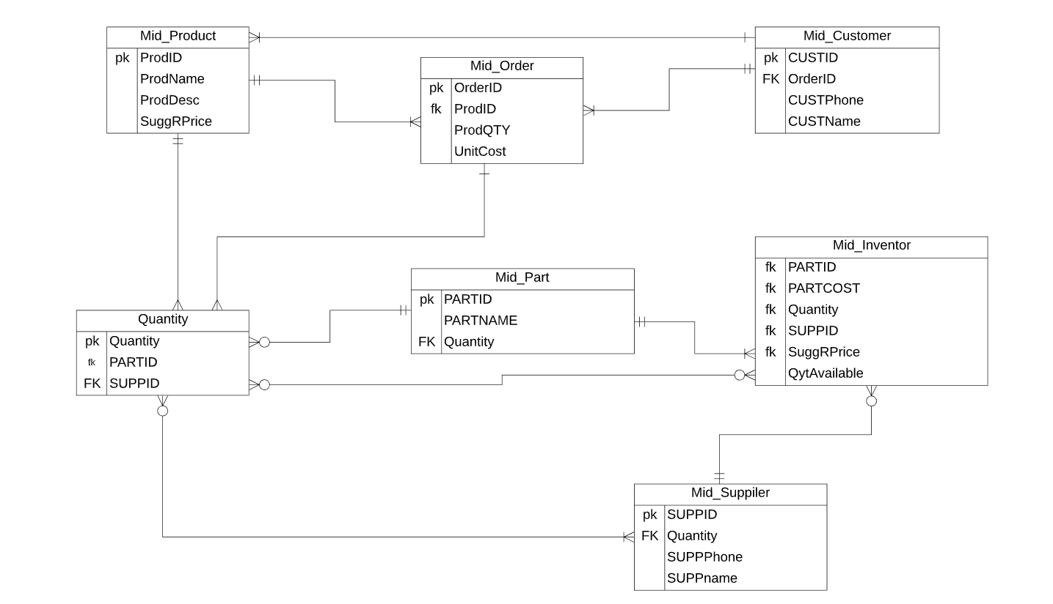

**PART B:**

**1. Display Lname, Fname and Salary of Employees.**

Select Lname,Fname,salary from Employee;

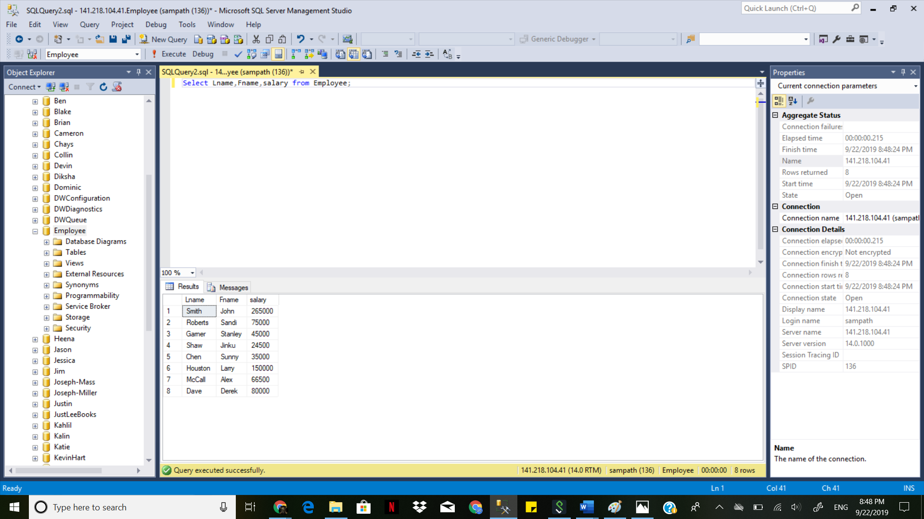

**2. Display Lname and Fname of Employee who work for the Finance department.**

select Lname, Fname from Employee where DeptId in ( select DeptId from dept where DeptName = 'finance')

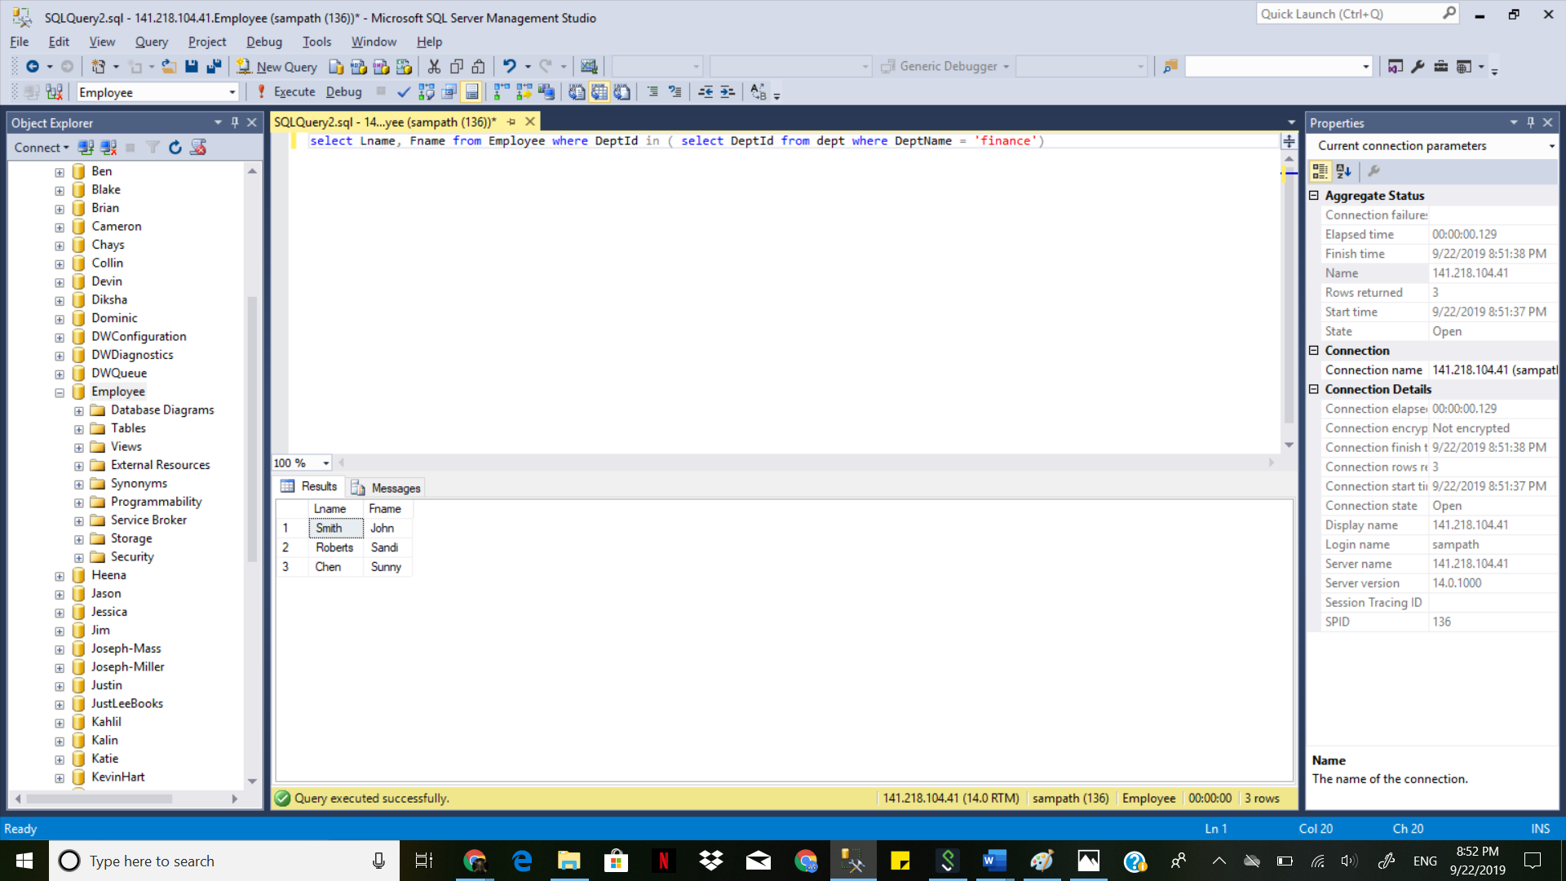

**3. Display Lname and Fname of Employee who has a Spouse.**

select Lname, Fname from Employee where EmployeeId in ( select EmployeeId from dependent where Relation ='Spouse')

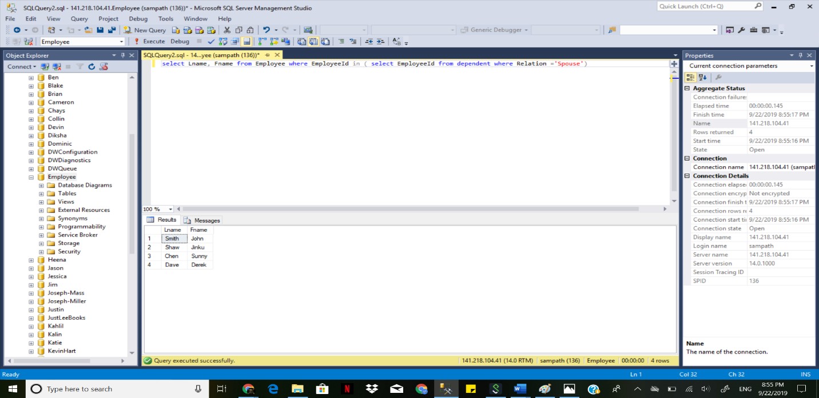

**4. Display Lname, Fname, DeptName, PosDesc of Employee who do not earn any commission.**

Select employee.Lname,employee.Fname,dept.DeptName,position.PosDesc

from employee inner join dept on employee.EmployeeId=dept.EmployeeId

inner join position on employee.PositionId=position.PositionId

where employee.Commission is NULL;

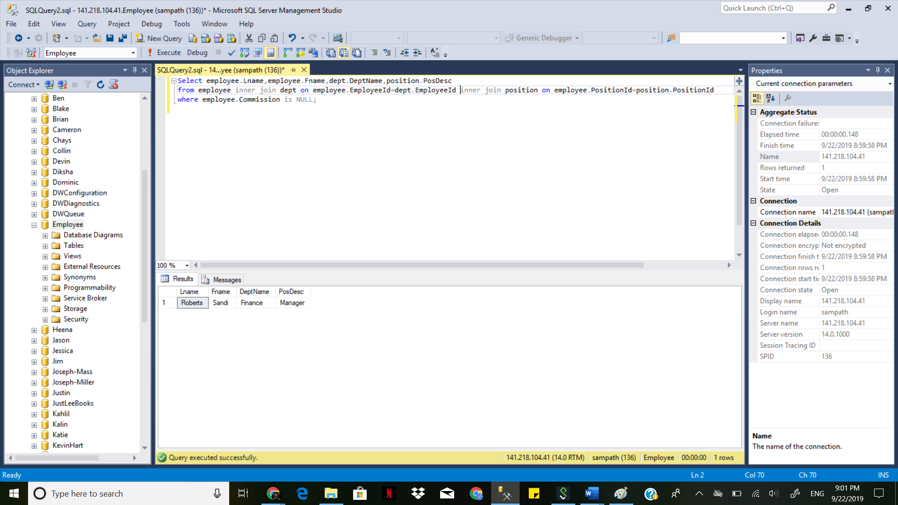

**BONUS QUESTION:**

Display Lname and Fname of Employee who earns a commission between the highest and the lowest. Highest & Lowest commissions must not be included in the result and cannot use any numeric value in the Query

Select employee.Lname,employee.Fname from employee

where Commission < (select MAX(Commission) from employee)

and Commission > (select MIN(Commission) from employee);

